Lab1 Report

Introduction:

I was given the task to draw shapes such as squares and circles by using lists and arrays to represent coordinate points which would be plotted. All of the problems given required me to come up with a recursive method to solve them. The first problem in this lab asks me to plot five squares in a very specific arrangement, where one square is about 4 times the size of the rest, and the remaining smaller squares have to be placed slightly inside and outside each corner of the larger square. The second problem in this lab required me to plot points to form a circle with smaller circles (looks like shrinking circles) inside it pushed towards the left. The third problem asked to plot points that form a tree (looks like a binary search tree). The fourth and final problem asked for one big circle plotted with smaller circles inside it plotted in the form of a cross.

Proposed Solution Design and Implementation

For the square problem I designed a method that takes the initial points given to form the first square and manipulate those points to form coordinates for a brand-new square. I would require a smaller number to multiply the given array to shrink the size of the square, then I would add a particular number to the new array formed to change its location on the grid. I ended up making four new squares by manipulating the original points to get the desired points. I call the method four times, each time with a different square in it.

The problem with the circle shrinking down toward the left, I just simply came up with a good starting center, numbers that were easy to work with, then I just simply moved the center of the circle over to the left by multiplying the list by a smaller number, and I made the size of the circle smaller by multiplying that same small number to the given radius. So, when I re-entered the variables in the parameters where I’m calling the method again, I multiply the center and radius by the smaller number.

The tree problem was the most difficult to come up with a solution for. The first thing I did was make a list of points that would form the shape of an upside-down v, and those points would be my starting points. Then, I split the tree up into right and left halves because the left side of the tree will have negative x-points and the right side won’t, based off of my starting points. For the left side I made a new list that got the points by subtracting a certain number (based off of calculations) from the original list, then I multiply only the x-point by a smaller number (based off of calculations) to give the slope a steeper appearance. The right half of the tree I only subtracted a number (based off of calculations) from the y-point, and for the x-points I do exactly what I did for the left side except add instead of subtract, and this time I add that same number at the very end so that the slope will be heading away from the origin instead of toward it. I call the method twice, once with the left side, and the other with the right side.

The final problem, the circle with other circles inside it forming in the shape of a cross, I used a method similar to the one I used to plot the shape from the first problem. I made four new circles, one for the top, bottom, left, and right. The method I made requires a center point to be entered to draw the first circle. For the left and right circles, I add 2 \* 1/3 radius (2 \* 1/3 radius because three circles take up the whole diameter, so 2\*1/3radius would give me the diameter of one of the little circles) to the x-point to go right, subtract to go left. Then apply this same concept to the top and bottom but instead of changing the x-point, I change the y-points. I called this method five times, each time with a new circle, and dividing the radius by three.

Experimental Results

It took a lot of trial and error to get the right number to plot the points to form the shapes in the problems. I had to print lists out to see the coordinates that I had versus what I was trying to get. First, I had to calculate the coordinates I needed, then I had to run a lot of tests to see if I was getting the proper coordinates when adding, subtracting, and multiplying to the lists.

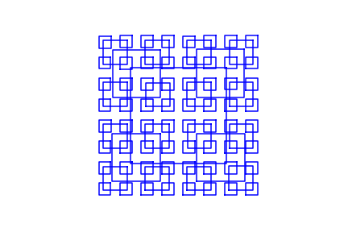





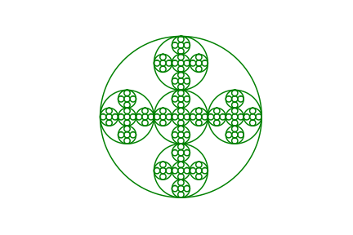

Conclusion

I learned that plotting points can sometimes be extremely difficult, especially when you know the coordinates that you want to find, but just can’t come up with the right formula to get those coordinates. I am now very familiar with adding or subtracting something to only a half of the list, and I am pretty familiar with indices after completing this lab.

“I certify that this project is entirely my own work. I wrote, debugged, and tested the code being presented, performed the experiments, and wrote the report. I also certify that I did not share my code or report or provided inappropriate assistance to any student in the class.”